 | Beacon Hill Football  (Football Section of Beacon Hill Youth Club Inc – over 50 yrs strong)  ………………………………………………………………………………………………  Monthly General Meeting  Monday, 29th June 2020  Minutes | 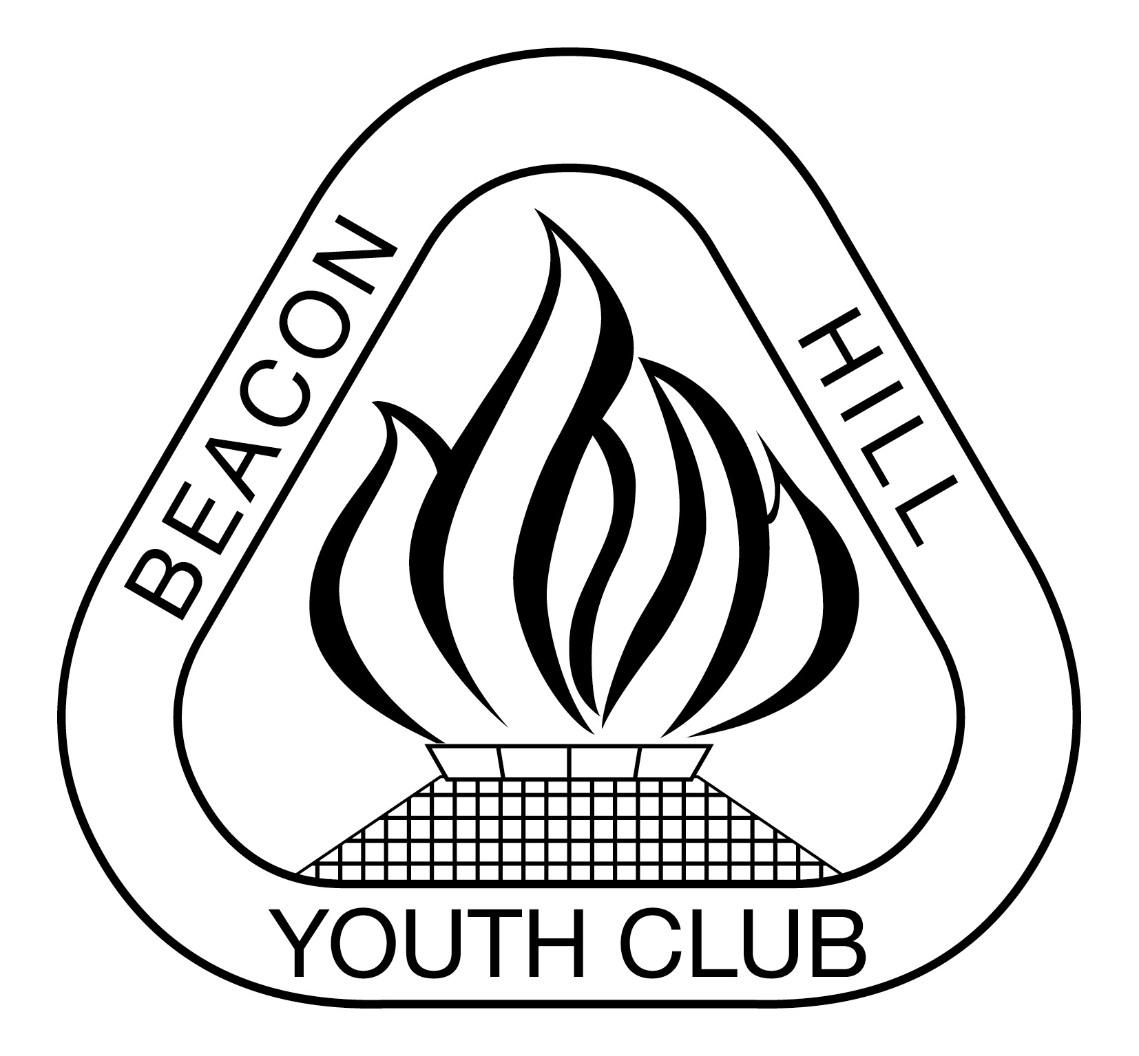
- Meeting Opened: By President, DYRSL club, 7.42pm
- Welcome: By President to Committee
- Attendance: Vince Vescio, John Koster, Marianne Hardy, Sam Falconer (left 9.50pm), Dan Ecans, Dusan M (left 9.00pm), Beth Sweeney, John Koster, Jason Koster, Gavin Nagle, Dan O’Brien, Matt Hermann (7.50pm)
- Apologies: Danny Holder, janelle Garland, Samantha Koster,
- Previous Meeting Minutes: 24/02/20
- Business Arising:
- Agenda: President asks if all have read Agenda
- Correspondence:
IN:
MWFA June Club Forum notes and confirmed Rule Change document. L4 Referee Course on-line on Sunday 21st June from 9am-3pm- Team Referees. Fair Trading information and Terms and Conditions for players re refunds. Return to competition 3/7/20 - Letter to players. MWFA Return to Play Guidelines. Various game changes. 2020 Deregistration and refund answers. Under 12 to U16 Parent Referee Course Monday 29th June @ Cromer Park Clubhouse 6.30pm. Forfeit Procedures. Team referees- AL8s need 1 more. Updated logins for EMS. Council fee update- No charge winter lights or levy. Canteens BBQs and physios. Your Clubs Member Protection Information Officer. Game Leader Courses Rescheduled various dates in July

Out: Request to trim trees at Bev Job & BH2. Updated MWFA field map guidelines from Karon MWFA re BH missing. Bev Job Mini field SE light is out. Allambie change room lock faulty- now rectified. U8 Draw issue

9) Reports:
President - (Vince Vescio) - Thank you to John organising kit bags, Sigrid and Dan for the coaches and managers meeting. Enjoyy season. WPL – excellent squad, good quality.

Vice President - (Dusan Mihajlovic) – should have additional gear by the end of the week – 14 boxes. Additional express post costs. Possible increase in price. 120-130 Polo shirts already paid for by Dusan so these should be used first before any other polo shirts are ordered. Dusan free Wednesday and Friday between 3.30-5.30 for helping coaches with teams.Inflatables have been removed from Tristarm canteen to use at the Cromer Park holiday parks. Still available if we want them.

Secretary - (John Koster) COVID-19 training attendance sheets, still not receiving all teams. Nets for Bev Job 1 League field are now stored in mini shed at South side of Amenity block (W1 key). Defib still to be kept at BH Change room. Allambie, Tristram & Bev job 1 nets are now back up to standard. Borrowing rules still the same but now relaxed from 4 to 6 players & 6 times per player.

Treasurer - (Sigrid Mulherin) – deregistration refunds of BH portion only.Our financial position is fairly stable as we don’t rely on canteens etc. However the reduction in total number of players will have an effect on our finances. Scout Hall has reduced our invoice for hire of the storage from $660-$440/quarter. No lights or sporting field hire will also assist. MWFA has also applied for grants on our behalf. GST refunds from Youth Club have still not been finalised due to other matters, see General Business.

Registrar - (Sigrid Mulherin & various assistants) - 846 players currently registered. Still registering players, last day for 1st round is Wednesday 8pm to MWFA register, so Tuesday in PlayFootball. Coahces/managers need to check EMS works.Some deregistrations but no more than normal. Last day for any registration is 30 July, but no reduction due to late registration. Tear drop flags to be purchased.

Junior Co-ordinator - (Debi Moffat / Marianne Hardy) - absent
Youth Co-ordinator - (Marianne Hardy) – all U6 and U7 teams full, keen to play. A big thank you to the AL1 and Morris for traning the 12/3. 11/2 also training at the same time, so AL1s may assist there if they are playing a game at end of session.

Women’s Co-ordinator - Various Assistants – Nil to report.
Men's O35/45 Co-ordinator - (Danny Holder) – nil to report.

Senior A/Ls Co-ordinator - (Jason Koster) – late entry of AL3B team.

MWFA Delegate - (Matt Herrmann) Eskys allowed spectator area but 1.5m distance must be observed & no more than 20. Difficulties with FNSW. Major competition finishes on 25/26 Sept and Major premiers will be determined by average points/game. Last weekend will be Oct 4/5 with 1 v 2, 2 v 3 etc. No Saturday night games for PLs at Cromer Park. Association has reduced costs as much as possible, may be refunds to members at end of season.

Groundsman - (Gavin Nagle) – line marking will be done before the weekend. Currently the council completely the lines and they need to be adjusted.
Coaching director - (Dusan Mihajlovic) –
CC Co-ordinator - (Dan Evans) – planning coaching meetings.
Sponsorship - (Matt Herrmann) - no grant application for Dee Why RSL

General Business:
  - BH Youth Club additional levy & poss request of loan – discussion re request from Youth Club re additional fees for 2019. Motion:
Motion 1 BHFC requests the 2019 BHYC financials and all related expenses to justify to our members the additional levy. Vote: Unanimous
If the BHFC Executive committee deem the financials to be in order then the following Motion is carried
Motion: To pay the BHYC the additional levy for 2019.
BHFC requests that if additional funds may be requested in the future, that the BHFC is made aware of this prior to the request.
  - Motion: To pay the additional BHYC fees for 2019. For: Against:
  - Motion 2: BJFC will loan BHYC necessary funds for August JobKeeper on the provision that it is returned within 7 days of the BHYC receiving the money from the government and that process to be formalised in writing and signed both the YC and the FC treasurers.Vote: 11 for, 1 Abstain.
  - Palladin – Samples are in.
  - Goal Keeper Coaching ( Marin Psalich)
  - MPIO – John Tansley???
  - WPL – 30-40 Polos with sponsor (Dusan has in stock) from previous sponsorship.
  - Additional polo shirts – available. Send email to teams re purchasing polos.
  - Big thank you to Morris Springfeld and the AL1 for training the 12/3. All players are keen and focused and are really enjoying their training sessions.
  - Spare shorts for players that are not able to purchase.
  - AL1 – no promotion and relegation, difficult for current AL1 team. Working on maintaining players for 2021, how do we hold onto everyone.
  - No 6, 8, 10, S, M, L shorts currently available.
  - Wet weather – games are on until otherwise notified. Facebook post. Fields checked on Sat/Sun mornings.
  - Check B and C can borrow from A.
  - Promotion/relegation for competitions other than PL/ALs
  - Discussion re benches. 3 per bench only. Decision for no benches to be put out.
  - Signs on fences to ensure people are aware of the regulations of guidelines.
  - Opportunity with new Parkway Hotel opening for sponsorship.
  - Goal Keeper training/coach. Prior to COVID-19 we had approved the training. Teams are still requesting goal keeper training.
MOTION: Goal keeper to be contracted for 6 weeks starting after school holidays. If successful contract will be extended. VOTE: FOR:: unanimous.
  - UNIFORM; base jersey $28.00
MOTION: To move to a supplier that can provide jerseys very closely matched to our current jersey that is located in Australia with a competitive price. VOTE: unanimous
  - MOTION: To ask Paladin produce another sample playing jersey with the modifications requested VOTE: Unanimous.
Modifications to be sent via the Sam’s to Palladin.
  - Team Photos – Sunday 26 July and Saturday 15th August. Nic Hermann will prepare schedule. Facebook post to advise dates.
  - Proposal to hold BHFC meetings on the 4th Monday of each month at Cromer Clubhouse

Upcoming dates to remember:
Main comp starts Fri 3/7/20

Next Meetings:

Football MGM - Monday, 27th July – TBA 7:30pm
MWFA CoC - Monday, 13th July – TBA/Zoom 7:30pm
BHYC Bi MGM - Tuesday 4th Aug – TBA/Zoom 8pm

Meeting Closed: 10.07 pm

