 | Beacon Hill Football  (Football Section of Beacon Hill Youth Club Inc – over 50 yrs strong)  ………………………………………………………………………………………………  Monthly General Meeting  Monday, 28th September 2020  Agenda | 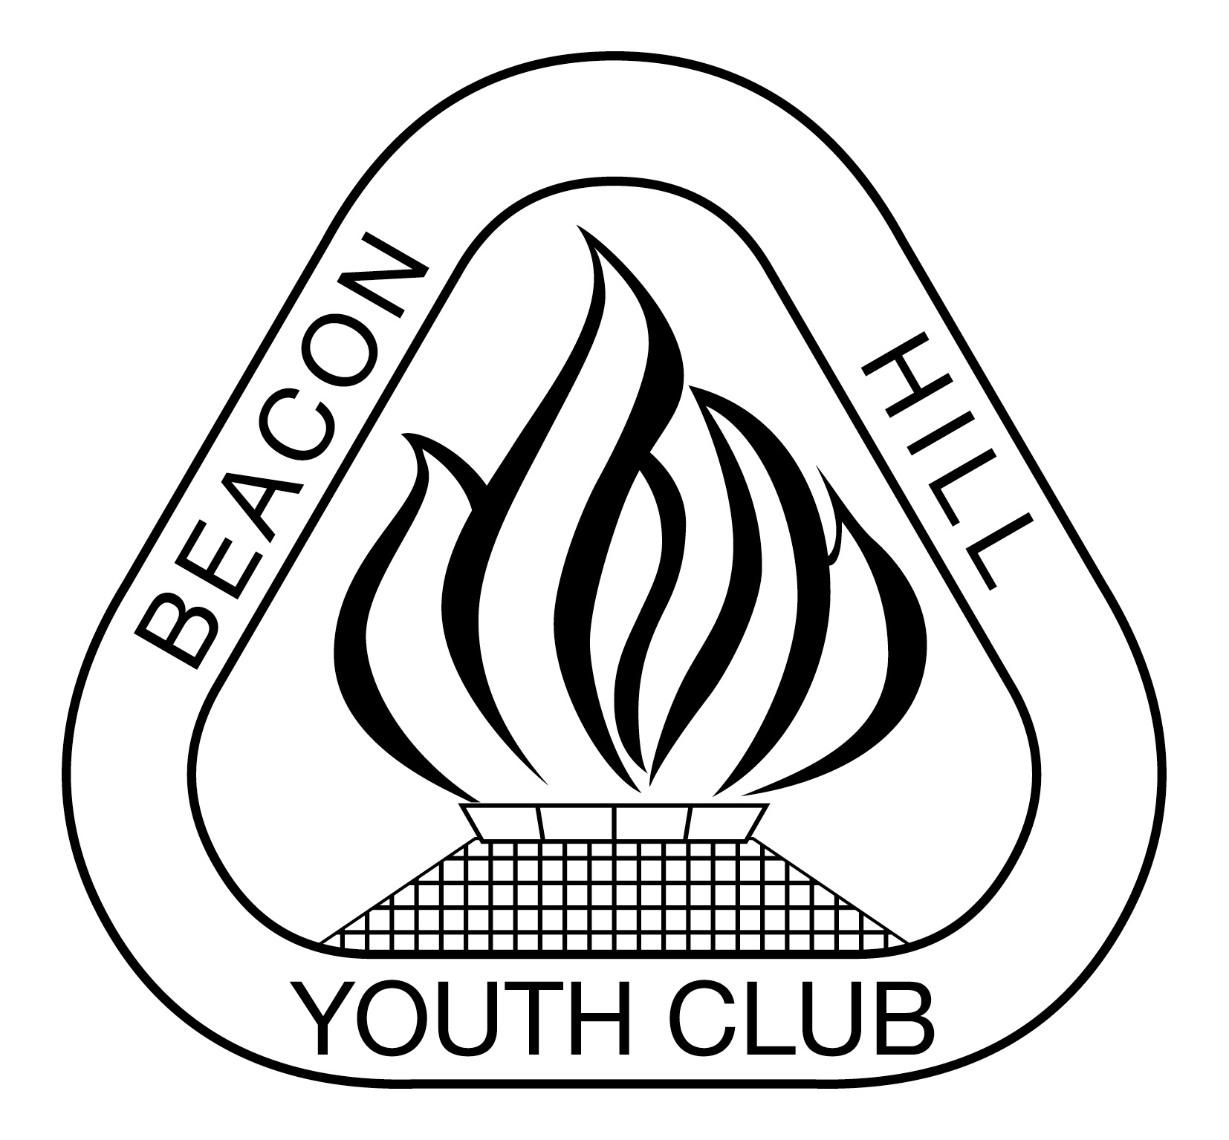
- Meeting Opened: By President, “Zoom”, 7.30pm
- Welcome: By President to Committee
- Attendance: Vince Vescio, Marianne Hardy, John Koster, Dan Evans, Sam Falconer, Sigrid Mulherin, Steve Gravemade, Daneil O’Brien (7.43pm) and Carolyn Deegan (7.43pm), Sam Koster (8.15pm)
- Apologies: Dan Holder, Jason Koster, Gavin Nagle
- Previous Meeting Minutes: 24/08/20 Approved: Marianne Hardy, 2nded: John Koster
- Business Arising:
- Agenda: President asks if all have read Agenda
- Correspondence:
IN: Senior C-Licence in November. 2020. MPL, AL1 and WPL, WAL1 - Player, Goalkeeper, Clubperson and Rookie of the Year Nominations. COVID Update - Presentation Nights and Northern Beaches venues identified. MWFA June Club Forum notes and confirmed. Rule Change document. Spectator report re WO40-2 B, Hill V Strikers on Strikers behaviour. MWFA Extra training and Academy review. MWFA Board minutes August FINAL. Manly United and MWFA trials for 2021. Boys U8 Gala Day matches at Cromer Park (reply by 16/9/20). MWFA September Clubs Forum Agenda. Offence - Refereeing - Beacon Hill AL9B. MWFA Meritorious Service Award Nominations due 19/10/20. Rule Changes - 25/9/20. MWFA Fee reductions by age group. MWFA v NSFA Champions Day on 11th October, 2020 Champion of Champions cancelled. Relaxation of one parent at game rules from this weekend 25th Sep. Radio recording regarding team withdrawal.

Out:. Allambie Oval Light at N/W corner not working. 2020 MPL, AL1 and WPL, WAL1 - Player, Goalkeeper, Clubperson, Goal scorers, Coach and Rookie of the Year Nominations. BH submitting a team for mixed U8 Gala Day matches at Cromer Park. Club financial position reminder for MWFA surplus reallocation due Wed 26/8/20.

9) Reports:
President - (Vince Vescio) – thank you to everyone for their commitment over what has been a difficult season without too many dramas. Thank you to Sam and Beth for ensuring the nets are taken down Sunday afternoons when away teams are at our fields. Request if away teams are scheduled for our teams then they are not put 1st or last of the day.Call from Alex Green, President of Mnaly Allambie FC to discuss a merge. MA advantages – financially healthy but small numbers in some age groups making it difficult to provide teams for everyone. A bigger club would proide more teams in all areas. Only 1 school that feeds into club. MVFC has 1200 players and feel they are taking over the MAFC fields. Another advantage would be the synthetic pitches being planned for Millers. Explained to Alec that we are part of Youth Club so that makes it more complicated. May be a good idea but practically not easy. It would make it the biggest club in the MWFA with a very large catchement area from Seaforth/Beacon Hill/Narraweena/ Allambie.

Vice President - (Dusan Mihajlovic) - absent

Secretary - (John Koster) BH#2 Lights rectified. Besteam submitted new sublimated prices matching our existing prices on shorts & jerseys. BH teams not packing away & various lock up problems (both away teams at 3pm Allambie left all equipment out and BH team on BH1 also left everything out). BH medallions will be ready for collection this Friday night. Manager to be informed.
Treasurer - (Sigrid Mulherin) – BHYC, have sent a 2018/2019 comparision of P&L. 2018 had a profit of approx $2000 with 2019 having a loss of $16000.00. There were no auditing fees listed for 2018. 2019 auditing fees were $8000.00. There is also a loss of $1500 in the collection of YCL. However these figures are only related to management fees and doesn’t aportion accounts that are related to the cricket and gymnastics section as separate. Final invoice reeived from MWFA.

Registrar - (Sigrid Mulherin & various assistants) – nothing to report

Junior Co-ordinator - (Debi Moffat / Marianne Hardy)
Youth Co-ordinator - (Marianne Hardy) 13/2 coming 2nd; 13/3 should be Major champions but have forfeited tomorrows game. 123 middle of the table.

Women’s Co-ordinator - Various Assistants – W12/1 are currently leading the competition with one game to go on Thursday.If they are Champions then they will be eligible for the MWFA v NSFA game on Sunday 11th October, Cromer Park 1 at 8.30am
Men's O35/45 Co-ordinator - (Danny Holder) – no senior teams have placed 1st or 2nd although the O45/3 only missed out by 0.25 of a point (after adjustments)

Senior A/Ls Co-ordinator - (Jason Koster AL9A are Major Champions and will play BTH in the final on Friday night at 7pm at Beacon Hill oval. AL3B came 2nd and will play Manly Vale on Friday night BTH at David Thomas. Femaile Player of the Year is currently receiving nominations. The AL1 came 2nd and will play FK on Saturday at 4pm at Melwood.

MWFA Delegate - (Matt Herrmann) – discussion re U17/U21 competition. Not much interest in the U17s competition as not enough teams in U18s. Discussion re behaviour at grounds. Discussion re Academy’s. Still to determine how trophy will be awarded.

Groundsman - (Gavin Nagle) -
Coaching director - (Dusan Mihajlovic) – absent
CC Co-ordinator - (Dan Evans) – the U10s went to the AL1 game and did the warm up with them and marched them out onto the field. Try to do something for this weekends AL1 final – 4pm at Melwood. Email sent out to collect information from coaches/managers on this years teams. Been talking to coaches at games over the past few weeks. Eugene from MWFA attended some U8 and U9 games on the weekend. Review of 2020 grading and will attempt to formulate a grading policy/protocol.Time line/dates for pre-season 2021.Coaching courses via zoom early in the season. Grading may have to be broken up if we have too many players in one age group.
Sponsorship - (Matt Herrmann ) - absent

General Business:
- Request use of Cromer Club House for AGM on the 26th or 28th October
- WPL Sponsorship money from Corretto – what to do with money they have paid this year? Going for full sponsorship for 2021.
- New jerseys - Palladin requires us to pay for second samples. Has held up process for new supplier. Do other supplies usually request payment? We gave them the jersey and what we wanted so if they had of done this the first time a second sample would not be required. Besteam has also approached the club at our current price – Shorts $17.50, Shirts $22.50 minimum order of 300 shirts and 400 shorts. Currently doing a sample. Do we need a sub committee to take this project forward?
- Awarding of Perpetual Trophies – how will these be awarded to the winners? Screencast – power point presentation with voice over? Video of announcement? Facebook announcement? Dan O’Brien to assist with screencast.
- Most successful team – AL1, only 1 loss and 2 draws, 2nd in competition; W12/1 – 1 loss, 4 draws but first in the competition.
- Nominations for 2021 committee.

Upcoming dates to remember:

MWFA Finals days: Fri 2nd, Sat 3rd & Sun 4th Oct.
MWFA /NSFA Champion days Sat 10th & Sun 11th Oct

Next Meetings:

Football MGM - Monday, 26th October – Zoom 7:30pm
MWFA CoC - Monday, 12th October – Cromer 7:30pm
BHYC Bi MGM - Tuesday, 13th October – Zoom 8pm
BH Football AGM - Monday, 12th October - TBC

Meeting Closed: Proposed for 9.36 pm

