 | Beacon Hill Football  (Football Section of Beacon Hill Youth Club Inc – over 50 yrs strong)  ………………………………………………………………………………………………  Monthly General Meeting  Tuesday, 14th May 2019  Minutes | 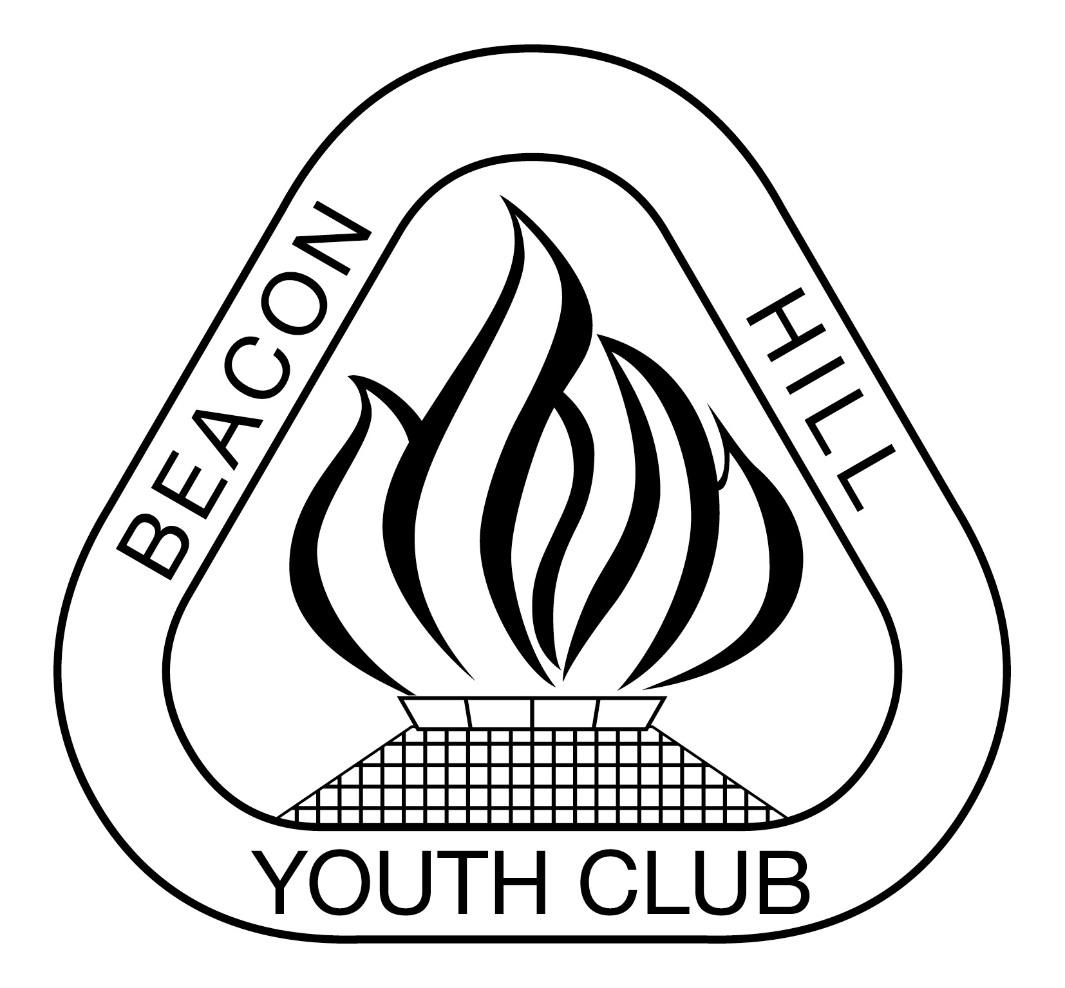
- Meeting Opened: By President, Parkway Hotel, 7.42pm
- Welcome: By President to Committee
- Attendance: Marianne Hardy, Vince Vescio, Matt Herrmann, John Tansley, Gavin Nagle, John Koster.
- Apologies: Dusan Mihajlovic, Helen Chambers,
- Previous Meeting Minutes: 28/03/19 – Accepted Matt Herrmann, 2nded Gavin Nagle
- Business Arising: Nil
- Agenda: President asks if all have read Agenda
- Correspondence:
Inward: MWFA Coaching Expo Thursday April 4. 2019 State Cup Entry Memo- U12-1 & WPL nominated. DYRSL 2019-2020 Community Support Program: Applications CLOSE Fri 12/4/19. Reminder about Defibs for all senior games. Manly Cup 2019 for U9 & U10 red teams. Referee Reminder. Wet Weather Procedures. New MiniRoos Coaching and Game Leader Courses Announced 11/4/19. FINAL April Council of Clubs and SGM Minutes. ISCORES for U8 to U11s. Various team ref offences. MIni Roos matches – offside. MWFA Coach workshops. 2019 MWFA Team Referees Sun 28/4/19. IMPORTANT information regarding injured players on the field. Forfeit Procedures. Booking - Accredited Mental Health First Aid Course for Clubs- JT is attending. Constitution Changes ahead of Monday's Council of Clubs Meeting. MEDIA RELEASE - Let's Light Up Football is back! WWCC coaches and Managers. Allambie Oval-Lights SMS issues 2/5/19. MWFA Gala Night Sat 31/8/19- discussed & majority voted for 2 tables again.

Outward: Various team responses to warnings. Question re two away teams on Bev Job mini- no reply.
On line request to have Bev Job lights checked out including branch trimming.
On line request to have BH#2 lights rectified & branch trimming
Request for more bins at Beacon Hill oval, currently only 2 bins now, not 3- now addressed with 5 yellow 240lt bins up there.
Email re storage at Bev Job & the Little Athletics storage area at Ben Love ammenity block & so far no response. Iscore issues.

9) Reports:
President - (Vince Vescio)- Thanks to Matt & Nic Herrmann re photo’s effort. A/L-1 Coach Maurice Springfeld has popped in on a few junior training sessions & is trying to get some A/L-1 boys to put some time in to assist at training sessions. Maybe Dan & Chris Lynch might be able to coordinate some sessions. Would like to see if Juniors could be encouraged to watch A/L-1s & maybe do a guard of honor or something at half time.
Vince wants to acknowlege Stuart Matters help & assistance in the CCC program & grading. Vince has got 2 of his Goal keepers to attend the A/L-1s goal keeping training for past couple of weeks & to assist paying for the cost, & was impressed with his training routine. Vince has asked would the Club be prepared to assist financially to the cost of the Goal keeper trainer for possibly 4 more sessions as so far both squads have been using sponsorship money to pay. All agreed to cover the next 5 sessions for the 2 squads. It was also discussed to look at utilising him for the Club & find out if there is interest in GK traing. Marianne said she would follow this up with the Coordinators & Vince to then negotiate a fee if it looks like we have intrest in GK training.

Vice President – (Dusan Mihajlovic) – Nil – John received a txt from Dusan saying that he believed our 2018 order has been despatched.

Secretary - (John Koster) – JB T/tops now $35 +GST (were $23 several yrs ago) Recommend we sell for $42 & accepted. Reminder of correspondence to go thru correct channel with MWFA. Still struggling to get teams to open up & close up where asked to. Have got a price from Rhino for spray Jkts @ $49.50, will obtain a sample to see if we want like them. A discussion regarding playing shorts for females was brought up, John mentioned that 1/3 of our Club is now female, but sees the logistics of supplying a female cut of shorts could be a nightmare in various ways. Most feel that this area needs to be looked into for the females & possibly for next season.
John brought up that this year he has found doing the roles of Secretary & gear a chore & not enjoyed doing his roles this year. He feels it’s time to step down. Gavin brought up succession planning & john stated that we need to look to the junior age group as that is where volunteers for the Committee generally come from.
Treasurer - (Sigrid Mulherin) – Nil

Registrar - (Helen Chambers & various assistants) - Nil

Junior Co-ordinator - (Marianne Hardy / Debi Moffat) – Some regradings have been happening.
Youth Co-ordinator - (Marianne Hardy) -

Women’s Co-ordinator – Various Assistants – See attachment.
Men's O35/45 Co-ordinator - (Danny Holder) – Nil

Senior Co-ordinator – nil

MWFA Delegate – The Council of Clubs voting system was voted on & the 4 big Clubs got the vote over the line to stay as is. It was brought up that the constitution states committee members are entitled to vote which then swayed the numbers back to a single vote per Club, as per recommendations given to MWFA. To be officially voted on at next meeting. Reccomendations also in trying to get all Clubs to have a set baseline of their own Constitutions.
It was mentioned there is money available for Clubs to come forward with reasonable projects for improvements.

Groundsman – (Gavin Nagle) – Grounds in need of water, BH2 was watered today. Trying a new line marking paint. Lock at Allambie change room needs attention. Am assisting at Beacon Hill Public School fair on Sun 26/5/19 & setting up a BHFC stall with Dusan’s blow up goal. Asking can Club donate some balls etc, for this is where our Juniors come from & want to promote our Club this section of our Community. All agreed to donate some BHFC balls & a boot bag. Also asked if anyone has spare time & would like to assist here.
Coaching director - (Dusan Mihajlovic) –
CC Co-ordinator –
Sponsorship – (Matt Herrman ) - Information we provided to Goodwill Hunting about BHFC’s current funding priorities, and;
Their suggested list of potential grants in 2019, which we could apply for. Application sent to DYRSL for $28,000. Trying to improve female participation via Good Will Hunting. Aust. Sports foundation have applied for. See Attachments

General Business:
Medalions-new supplier is being organised by Kerrie Koster as Old supplier not doing them anymore. Some samples shown, most felt we should change to our Football logo from the Youth Club logo. John will get Kerrie to ask for Our Logo samples.
Presentation night. Vinces thoughts on presentation was to do a BBQ at School oval for all. Discussions were had on how its been going, Matt, Gavin & JT thought it was fine as it is currently being done in the separate groups so it looks like it will stay that way.
JT asked if a reminder could be added to the Home field draw John sends out on Friday afternoons. John K concerns not many look at it anyway to pass on to the relevant teams.

Upcoming dates to remember:
Advanced Life Photo Dates 2019 - Sat 11th May, Sun 12th May, Sat 18th May

Next Meetings:

Football MGM - Monday, 27th May 2019 TBA – 7:30pm
MWFA CoC - Monday, 3rd June 2019 Cromer – 7:30pm

Meeting Closed: 10.45 pm

