 | Beacon Hill Football  (Football Section of Beacon Hill Youth Club Inc – over 50 yrs strong)  ………………………………………………………………………………………………  Monthly General Meeting  Monday, 24th August 2020  Agenda | 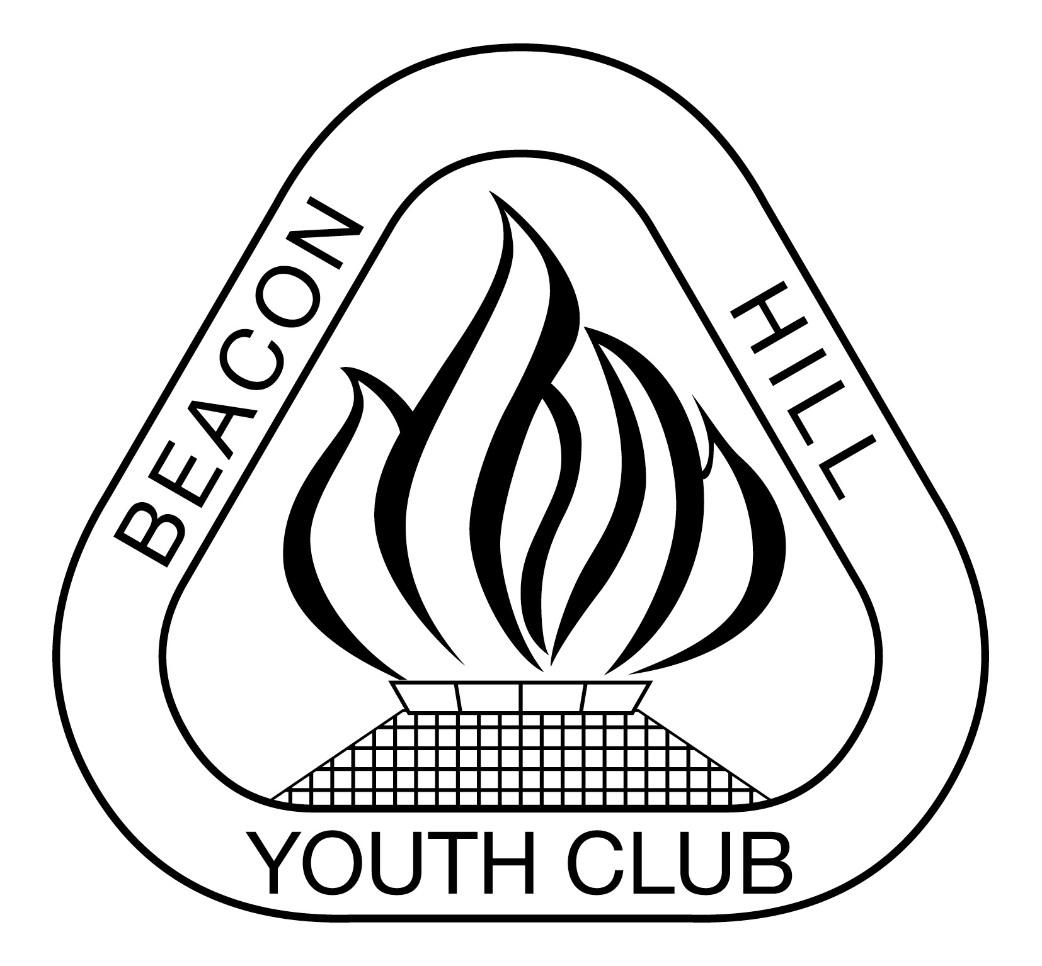
- Meeting Opened: By President, “Zoom”, 7.38pm
- Welcome: By President to Committee
- Attendance: Jason Koster, Sam Koster, Sigrid Mulherin, Dusan Mihjolvic, John Koster, Steve Gravemade, Matt Herrmann, Vince Vesio, Carolyn Deegan, Daniel O’Brien,
- Apologies: Marianne Hardy, Sam Falconer, Beth Sweeney
Absent:
- Previous Meeting Minutes: 27/07/20 Accepted: Matt Herrmann, 2nded: Vince Vescio
- Business Arising: Club still does not have a MPIO officer. No current courses available
- Agenda: President asks if all have read Agenda
- Correspondence:
IN: Results Not Loaded into EMS U8-U11 & W8-W11. Behaviour on the sideline W16-2B 26/7/2020-Resolved. Goal nets still up during the week. COVID Safety visits by NSW Health. MWFA v NSFA Champions Day - 2020 Champion of Champions cancelled. July MWFA Board Minutes FINAL. Updated Handbook V3 2020. MWFA Club Forum agenda and supporting information. Please remind your teams and players to be vigilant with COVID-Safety. Various regrades have been done. MWFA Disciplinary Point system explanation for teams. MWFA Club forum notes and IMPORTANT information. MWFA Extra training and Academy review – Dusan said he would attend. Cromer Park Clubhouse Development. Chief Health Officer Letter to Sport and Recreation Organisations - Monday 17 August 2020. Manly United and MWFA training compensation agreement announced. Offence - Refereeing - Beacon Hill AL4, resolved. Updated COVID-19 information. Club financial position reminder for MWFA surplus reallocation due Wed 26/8/20. Reply re Referees at U6/U7 games- preferred both sides provide 1 ref each. Incident at WPL on 23/8/20 at Grahams Oval, spectator inside the fence. Beacon Hill Community Hall Meeting Room now available for hire but can only accommodate 5 people at a time

Out: Council notified of pop up sprinkler problem on Tristram2. Referees at U6/U7 games.

9) Reports:
President - (Vince Vescio) – thank you to Matt and Nic Herrman for attempting to organise Team Photo’s – unfortunately they have had to be cancelled due to the recent guidelines. Money from WPL 2019 – purchase polo’s for players. No mention of BH when MWFA discussing too many spectators etc.

Vice President - (Dusan Mihajlovic) – Dusan is available to assist coaches with their training sessions.

Secretary - (John Koster) Lights rectification- Bev Job completed, BH still has 2 not working under 100 lux. We appear to be losing pop up goal bags to contain the goals in. Besteam specials on 3 items & price on playing shorts & tops (can match price but required to purchase 1000 items). Allambie Oval lights need to be checked.
Treasurer - (Sigrid Mulherin) – response from Youth Club, sent back request for actual P&L not just a list of expenses. There are a number of expenses included in management fees that are not related to the FC. No evidence that the $10,000 has been paid, only invoices for less than $5,000. No response to the BAS for April to June. All progressive payments have been completed. One outstanding payment to John for reimbursement and an AKV to be refunded.

Discussion re what we as a club are going to do re return of surplus funds. Options include”
- Refund to players
- Reduction to 2021 players
- Capital raising fund.

VOTE: The club will return the surplus funds to the players.
Discussion re leaving vote for 2 weeks to gather further information regarding what other clubs are discussing. Vote will be electronic, via email.
Information to

Registrar - (Sigrid Mulherin & various assistants) - additional player in the AL3A and a player transferring from FK to the W16/2. No other changes. Enquiry re deregistration from O45/1 – hasn’t played a game. Could only refund the $121 BH portion of the fee. I could ask MWFA if they can deregister him due to the fact that he hasn’t played a game. Injury to AL1 player- insurance forms have been signed.

Junior Co-ordinator - (Debi Moffat / Marianne Hardy) - absent
Youth Co-ordinator - (Marianne Hardy) - absent

Women’s Co-ordinator – Sam Koster – net roster being forwarded from John’s with particualar women’s teams highlighted. All teams currently enjoying the season.
Men's O35/45 Co-ordinator - (Danny Holder) - absent

Senior A/Ls Co-ordinator - (Jason Koster) – nothing to report.

MWFA Delegate - (Matt Herrmann) - further discussion regarding U17s and U21 age groups. Query regarding women’s – but they don’t have the numbers. Concern of drop off in number of U18s – nearly halved from previous years. Discussion ongoing around Academy review – FNSW has been trying to set this up for a few years and to level the playing field so that parents do not have to pay just to play in a team. Behavioural forum/workshop. Note regarding abandoned games, only finished if due to injury.

Groundsman - (Gavin Nagle) – fields are being marked on Thursdays. Goal area on BH1 is being destroyed possibly due to a personal trainer. Lines quite faint on BH2 by Sunday afternoon so may need to be chalked instead of paint as the grass is dormant
Coaching director - (Dusan Mihajlovic) – available for coaching
CC Co-ordinator - (Dan Evans) - absent
Sponsorship - (Matt Herrmann) – working on event grant from council. All applications to Dee Why for sponsorship have been cancelled.

General Business:

- Trophies: Do we do trophies for 2020? Trophies or something to acknowledge that they have won the competition. VOTE: To provide a trophy or something in lieu of a trophy for the major competition U18s. FOR: 8 AGAINST: 1 ABSTAIN: 1 CARRIED
- VOTE: VOTE: To provide a trophy or something in lieu of a trophy for the major competition of senior teams. FOR: 5 AGAINST: 3 ABSTAIN: 1 CARRIED
- Medallions for U6-U16s. Purchased in 2019.
- Sportsperson of the Year Award? Data has not been collected and collated so far.
VOTE: To provide Sportsperson of Year Awards for each team in 2020 FOR: 7 Against: ABSTAIN: 1 CARRIED
- Reallocation of Surplus money- 1page plan due 23rd Sept.
- Female toilets at Beacon Hill – are not being kept clean and tidy. Complaint should be forwarded to the council.
- Reminder to all U8-U11 and W8-W11 to ensure scores are entered before Sunday night otherwise a fine of $5 is incurred.
- Couple of junior teams participating in Purple Socks down.

Upcoming dates to remember:
Photo’s: Sat 12th & Sun 13th Sept
MWFA Finals days: Sat 3rd & Sun 4th Oct.
MWFA /NSFA Champion days Sat 10th & Sun 11th Oct

Next Meetings:

Football MGM - Monday, 28th September – Zoom 7:30pm
MWFA CoC - Monday, 14th September – Cromer 7:30pm
BHYC Bi MGM - Tuesday 13th October – Zoom 8pm

Meeting Closed: Proposed for 9.32 pm

