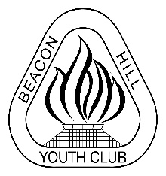
Beacon Hill Football Club
A Division of Beacon Hill Youth Club

MatchSheet Offences

Types of MatchSheet Offences
- The home team fails to supply a Match Sheet,
- A team fails to correctly complete the appropriate portions of the Match Sheet
- The MWFA is notified by the team’s Club that the team did not notify the Club of the result so it could be submitted before the required time, the team shall be subject to the following sanctions at the discretion of the EC

- First time the team is issued an informal warning in writing that they have committed an offence.
- For the second time the team is issued a formal warning in writing that they committed an offence and further offences of a similar nature will mean loss of Competition Points.
- For the third and subsequent times the team will lose one Competition Point.

Please see attached examples of a Match Sheet and a Competition Team Sheet specifying the requirements of the Home and Away Team for completing parts of the Match/Team Sheet.
The punishment will only apply for one or more errors on the same Match Sheet.
This system will commence in round 3
Before round 3 warnings will be issued for each offence but these warnings will not count towards any penalty until after round 3.
Clubs are reminded the PL first and reserves, AL1 and AL2 first and reserves are to use the triplicate MWFA Match Sheet as used in previous seasons.
All other age/divisions from under 12’s to over 45’s, including AL3 and below and WPL and WAL1 must use the ICompan Match Sheets.

