 | Beacon Hill Football  (Football Section of Beacon Hill Youth Club Inc – over 50 yrs strong)  ………………………………………………………………………………………………  Monthly General Meeting  Monday, 27th July 2020  Agenda | 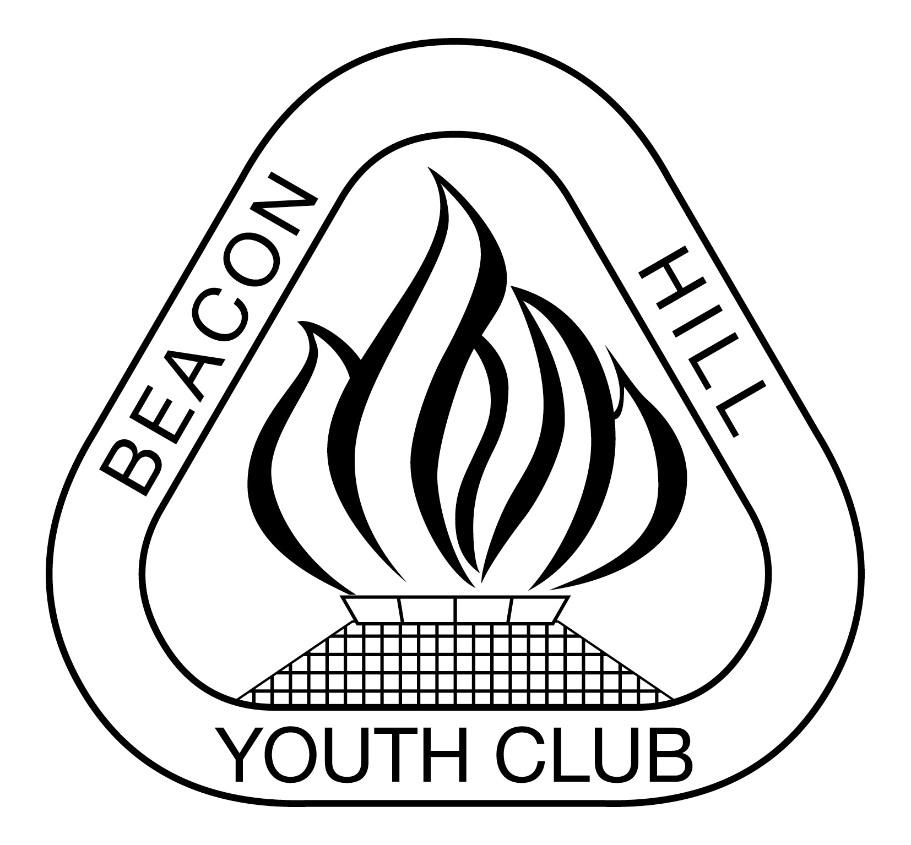
- Meeting Opened: By President, “Zoom”, 7.30pm
- Welcome: By President to Committee
- Attendance: Marianne Chalmers. Sigrid Mulherin, Vince Vescio, John Koster, Sam Falconer, Matt Chambers, Gavin Nagle, Jason Koster, Carolyn Deegan
- Apologies: Dan O’Brien, Sam Koster
- Previous Meeting Minutes: 29/06/20
- Business Arising: MPIO position still not filled, no further courses being run
- Agenda: President asks if all have read Agenda
- Correspondence:
IN: MWFA Return to Play Guidelines and ZOOM Meeting. COVID19 Safety Plan replied signed off & returned. All Coaching Courses Rescheduled.
MPL, AL1, WPL and WAL - Players of the Year & golden boot Voting. MWFA Team Referees. Updated logins for EMS. MWFA Board minutes from Monday night - June 2020. Thank You and Good luck. Female Only MiniRoos Coaching Course. Club representative on Disciplinary Committee (BH is wed 12/8/20) – Terry Redmond said he would do this one. Thanks, and a key message. Agenda for Monday night MWFA Club Forum - at the MWFC Clubhouse. FINAL MWFA Club Forum notes from Monday - July meeting. Northern Beaches Council- please don’t call Council re if grounds closed. WPL manager or coach to text match results to Lee-Anne 0417 265 276. Code 5 Fitness possible sponsorship request. Beacon Hill FC - Poker Night - Helping You Get Back into the Swing of Things-fundraiser. 2 x WAL games replay leftover time remaining Tue 28/7/20. COVID-19 PLAY IT SAFE & REDUCE THE RISK. Update of Handbook for 2020. Updated COVID Safety Plan. Request for player exemption for Beacon Hill women's over 40 Div 2 team - denied
Out: Request for player exemption for Beacon Hill women's over 40 Div 2 team.
Online & email Request to fix 2 lights (100lux affected only) at BHO2. Online Request to fix Female toilet Leak at Tristram & install soap dispensers in both toilets. Online Request to rectify BH Community Hall pathway lights.

9) Reports:
President - (Vince Vescio) – MWFA have contacted club to enquire if any major issues. Goal keeper training was to start this week but due to weather postponed until next week. WPLR are doing well, WPL currently havve 8 players out with bad injures, currently haven’t won a game. Vince’s last year as president, will not stand in as president for 2021. Would like to stay in a smaller role to assist anyone who is willing to take over as president.

Vice President - (Dusan Mihajlovic) - absent

Secretary - (John Koster) Below is the NBC online request for any issues - link FYI, or ring 9942 2111 https://help.northernbeaches.nsw.gov.au/s/?utm_campaign=Website&utm_medium=Homepage+Icon&utm_source=northernbeaches.nsw.gov.au
2019 gear order arrived.
Treasurer - (Sigrid Mulherin) – received $1000 grant from government, may have to split with Netball. Only 18 deregisrations this year, with only 4 from COVID (2 juniors, 1 senior mens and 1 senior womens). Have requested P&L from Youth Club and evidence of extra expenses – this is still to be provided. GST from 3rd quarter 2019 still not resolved as wrapped up in the additional funds the YC is requesting.

Registrar - (Sigrid Mulherin & various assistants) - 871 players , 78 (8%) less than 2019. 78 coaches and 57 managers. 22 junior mixed teams, 3 mixed youth teams, 9 senior mens teams and 5 O35/045 teams, 7 junior women’s teams, 8 womens youth teams, 6 senior womens and 1 W40s.

Junior Co-ordinator - (Debi Moffat / Marianne Hardy) , junior teams are happy to be out on the field, youth teams are going well.. 11/5 winning by big scores (they have an ex-SAP player in the team who is a cousin of one of the other players)
Youth Co-ordinator - (Marianne Hardy) 12/3 really enjoying the training by the AL1

Women’s Co-ordinator - Various Assistants
Men's O35/45 Co-ordinator - (Danny Holder)

Senior A/Ls Co-ordinator - (Jason Koster) – teams are doing OK, AL1s doing very well, AL3s both top 4, Intellectually disabled player recently registered in AL9B team, very keen and happy to play. Vince – watched AL1/R, coach is doing a great job.

MWFA Delegate - (Matt Herrmann) – BH1 will get light upgrades next off season. Only association in the state where registrations have increased since 2019. There is likely surplus funds at the end of season and discussion on how they will be used or returned to players. No Champion of Champions but there have been discussions with Northern Suburbs to hold a CofC day between the two associations for Div 1 teams. Reiteration that there are to be no BBQs due to COVID-19. Storage facilities – needs 3m wall. U17 and U21 and O55 competitions being considered.

Groundsman - (Gavin Nagle) – fields will be remarked. Beverley Job lights need updating. Escalate enquiry as they told us it would be 3-6 months and it has now been 12 months. Photo’s of the issues to send to council.
Coaching director - (Dusan Mihajlovic) – absent
CC Co-ordinator - (Dan Evans) - absent
Sponsorship - (Matt Herrmann) – council grants for events and equipment for events eg holiday camp equipment.

General Business:

- Notify MWFA that two lights are out at Beacon Hill – no longer 100 lux.
- Team Photos – 15/16 August. Schedule will go out 13th August
- Goal Keeper training
  - 4.30-5.30pm – U8s to U11s (potentially 13 participants)
  - 5.30-6.30pm – all youth
  - 6.30-7.30pm - senior teams (4 minimum)
- Council fining cars parked on the grass surrounding Tristram Oval.

Upcoming dates to remember:

Next Meetings:

Football MGM - Monday, 24th August – TBA 7:30pm
MWFA CoC - Monday, 13th July – TBA/Zoom 7:30pm
BHYC Bi MGM - Tuesday 4th Aug – TBA/Zoom 8pm

Meeting Closed: Proposed for 9.30 pm

