 | Beacon Hill Football  (Football Section of Beacon Hill Youth Club Inc – over 50 yrs strong)  ………………………………………………………………………………………………  Monthly General Meeting  Monday, 29th July 2019  Minutes | 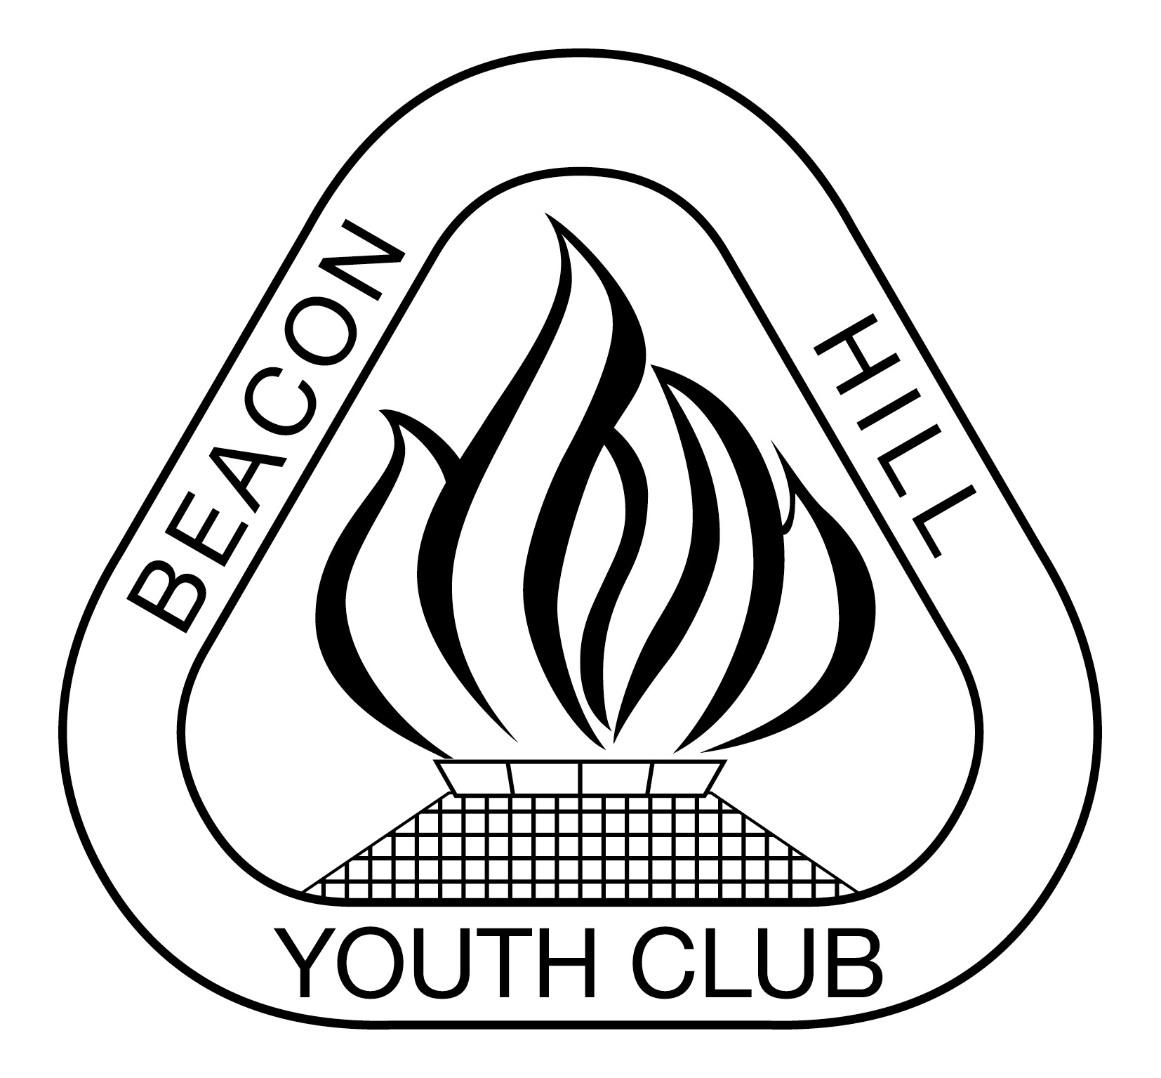
- Meeting Opened: By President, Parkway Hotel, 7.43pm
- Welcome: By President to Committee
- Attendance: John Koster, Matt Herrman, Gavin Nagle, Dusan Mihajlovic, Sigrid Mulherin
- Apologies: Vince Vescio, Helen Chambers, Danny Holder, Maria Pollard, Marianne Hardy
- Previous Meeting Minutes: 24/06/19 Accepted: Matt Herrman; 2nded: Gavin Nagle
- Business Arising: Only 2 responses from AL teams regarding an end of season function for all senior teams.
- Agenda: President asks if all have read Agenda
- Correspondence:
Inward: $15 fines to Club re U8-11s no EMS scores. FFA Inclusivity Principles for Club Identity. Mental Health First Aid course – CONFIRMATION – JT attending. 2019 MPL, AL1 and WPL, WAL1 - Player, Goalkeeper, Clubperson and Rookie of the Year Nominations. MUFC Corporate Box and Mascot Experience "Sun 28/7/19 3pm @ Cromer". MWFRA Citation Report Form Submission (6504),

Outward: Allambie Oval proposed playground- concerns sent to Di Smith Council re fencing may be required for playground safety. Storage issues for Beacon Hill Football resent to Di Smith – Mark Wilson is following this up & has given a quick possible solution. Assault incident Sunday 21 July, 2019 - Millers Manly Vale field Beacon Hill WO30-1A v Forest Killarney.

9) Reports:
President - (Vince Vescio)- Vince is away from 10th July – 14th August.

Vice President – (Dusan Mihajlovic) – Nil to report – merchandise order waiting on top up of any urgent items required, ie female shorts etc– john to inform Dusan of extra items

Secretary - (John Koster) – One aluminium bench stolen from Tristram has been found & back in Tristram toilet block. Beacon Hill 2 oval net destroyed Sat night 20/7/19 & has been replaced. BH2 net was found ripped to shreds Sunday morning 21/7/19 – has been replaced – do we continue to leave nets up overnight ? yes at this stage. Allambie lock problem was looked at & thought repaired by Council, they will follow up again. Light at Bev Job followed up 21/7/19 by Dave Dwyer -Council & will get bucket truck to rectify. New Beanies now in stock – now cost $13.75 –suggest we sell caps & beanies for $17 not $15 due to price increase? Vote: Unanimous to increase price to $17. Duncan Kerr – re Mental health, will come at a later date when we have more attending- possibly look at if members want to attend. (Scouts use Scout Hall Mon & Tue nights- Wed to Fri are available at present). New contractor to complete the Community Centre renovations appears to have started.

Treasurer - (Sigrid Mulherin) – currently finalising 2nd quarter to send to accountants. 1 outstanding Progressive Payment, outstanding duplicate payment of AKV, still trying to determine if we have been paid the correct amounts from PlayFootball -there were a couple of days where no payment was received despite their being reports, have not received final registration invoice from MWFA, attempting to finalise the AL1 sponsorship/expenses/player payments.

Registrar - (Helen Chambers & various assistants) – final registrations – 930 player
registrations.

Junior Co-ordinator - (Marianne Hardy / Debi Moffat) – Debi is away from 25 June - 22 July
Youth Co-ordinator - (Marianne Hardy) – no report

Women’s Co-ordinator – Various Assistants – no report
Men's O35/45 Co-ordinator - (Danny Holder) – no report

Senior Co-ordinator –

MWFA Delegate - (Fab Vescio) –

Groundsman – (Gavin Nagle) –
Coaching director - (Dusan Mihajlovic) – Nil
CC Co-ordinator –
Sponsorship – (Matt Herrman ) -

General Business:
- Duncan Kerr – Mental health. On hold until a later date when people can attend.
- 17 of 37 competitive teams in top 4, 6 other teams sitting in 5th place. 7 teams in 1st place
- Possibly looking at holding 16/18s presentation at end of Jnrs on Sun 18th Aug as only 3 teams in 16/18s
- Only WPL in running for Champion of Champions.

Upcoming dates to remember:
Junior Mixed Finals Sun 18th Aug
Senior Finals Sat 24th Aug
Womens Finals Sun 25th Aug
MWFA Gala night Sat 31st Aug
U16-18s Presentation Fri 13th September – BH Scout Hall (booked)
O35-45 presentation night 21st Sep @ Manly Leagues Club
Junior & Youth Presentation 22nd September BHPS Multi purpose hall
A/Ls & WALs - 14th September suggested & possibly @ Brookvale Hotel as is a sponsor of AL1s & WPLs

Next Meetings:

Football MGM - Monday, 26th August 2019 Parkway – 7:30pm
MWFA CoC - Monday, 5th August 2019 Cromer – 7:30pm

Meeting Closed: 8.50 pm

