 | Beacon Hill Football  (Football Section of Beacon Hill Youth Club Inc – over 50 yrs strong)  ………………………………………………………………………………………………  Monthly General Meeting  Monday, 26th August 2019  Minutes | 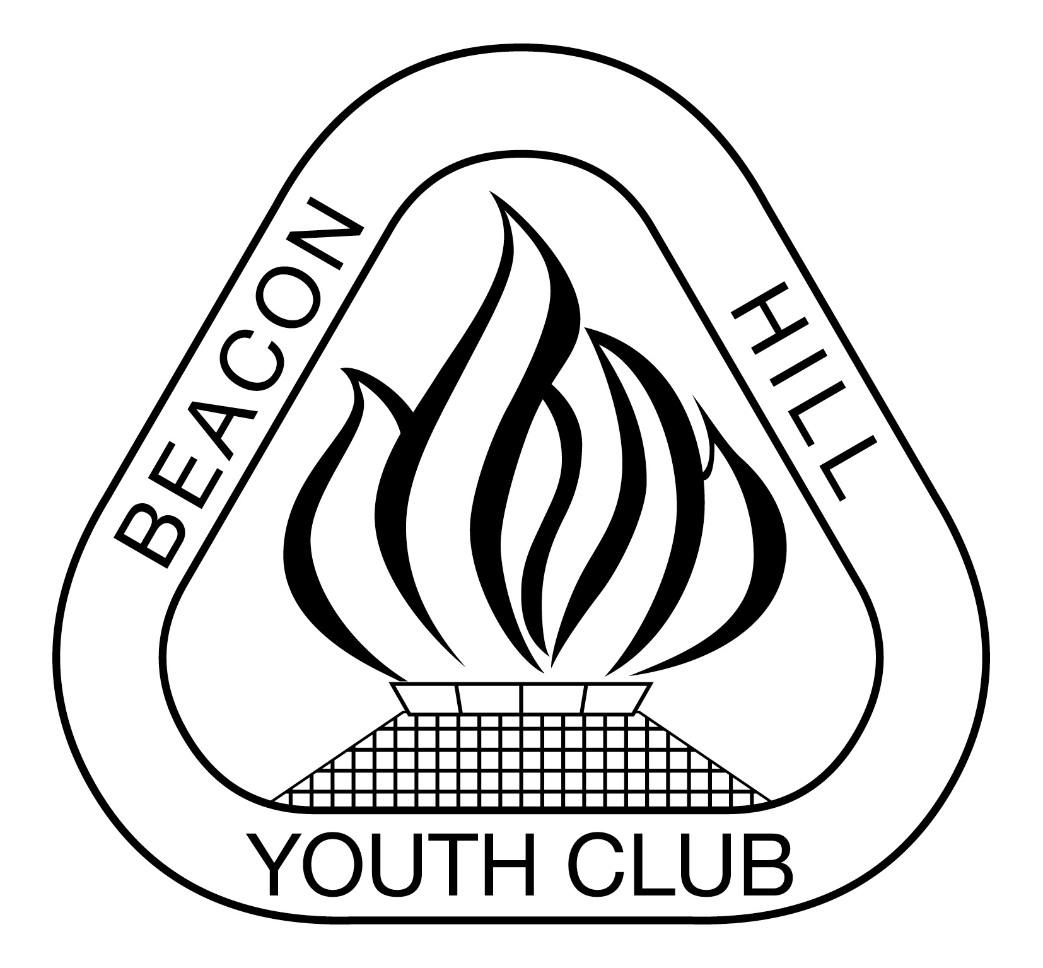
- Meeting Opened: By President, Parkway Hotel, 7.39pm
- Welcome: By President to Committee
- Attendance: Vince Vescio, John Koster, Marianne Hardy, Gavin Nagle, Matt Herrmann, Sigrid Mulherin, Dusan Mihajlovic
- Apologies: Danny Holder, Maria Pollard, Michele Lee, Helen Chambers
- Previous Meeting Minutes: 29/07/19 Accepted: Matt Herrman 2nded: Dusan Mihajlovic
- Business Arising:
- Agenda: President asks if all have read Agenda
- Correspondence:
Inward: AL1 / Premier League Play-off match. End of season 2019 functions, Zone bowling DY. Semi Finals & Finals. MWFA Finals Club duties – only 4 volunteers. 2019 MPL, AL1 and WPL, WAL1 - Player, Goalkeeper, Clubperson and Rookie of the Year Nominations etc. MWFA Council of Clubs AUG agenda and information. Missing Scores from U9 -11s - $5 fine per missing score. Team Referees - Round Robin Competition. Reminder Forfeit Procedures. TDP warning BH AL1. FINAL August Council of Clubs Minutes. Borrowing Rules SF / RR and Finals. Cambodia Gear Collection. Bubble Soccer for your End of Season Presentation. P&D 12-5s Final outcome - dismissed. Sportsground Allocations Summer Season 2019/2020 Final.
DYRSL Funding – given $6,000. Application for Community grants program for minor infrastructure (eg lawn mower) via Alice Taylor from Goodwill Hunting – unfortunately not successful. Girls Try SAP.

Outward: 2019 MPL, AL1 and WPL, WAL1 - Player, Goalkeeper, Clubperson, golden boot and Rookie of the Year Nominations all sent. P & D 12-5s Final result.

9) Reports:
President - (Vince Vescio): WAL1 started the season not as strong but ended up in the grand-final. WPL could have also won the major premiership but a few games throughout the season were lost that should have been won. Started recruiting for next year. Annalise and Mark helped out in Vince’s absense with assistance from Paolo – thank you to all. Have decided not to stand for President for 2020. Have mentioned this before but this time I will not take the role – the club needs fresh ideas and new people on the committee. Will remain with the club as MWFA Delegate or similar role.

Vice President – (Dusan Mihajlovic) – was not able to watch the grand-finals due to being away but it is clear that our Youth have done well this year, all 12s in finals and 13s only just missing out by a penalty shoot-out. Previously damaged by the creation of the AYL
which is an advantage for players but has seen our club with less youth teams at high divisions. Also our facilities are not adequate to attract players, and we need to find someone to facilitate the CCC program. I willl have more time for grading in 2020. Club focus should be on the U9-U12s for our future. BH Academy in Term 1 again. Soccer camp in January? Discussion re free rego for a child if anyone taking on a committee position such as age coordinator or CC coordinator or team coach for U6-U16. Use a school holiday camp to fund this incentive. Can hold trials for all grading on Saturday and Sundays at Calabrian Club if booked early and also available for trial games.

Secretary - (John Koster) – Fri nights on till end of Sept for team kits return. Tristram #1 nets replaced. Thank you to Danny Holder, Marianne Hardy, Nic Townsend & Brian
Barkworth (Barky) for doing the MWFA Club duties yesterday. Going to push Council for metal storage cage for bins at Tristram; bins currently stored in female toilets restricting their access.
Treasurer - (Sigrid Mulherin) – still waiting for final invoice from MWFA; 2nd quarter finalised and sent to accountant, should receive large GST refund; attempting to follow up on outstanding payments. Organisation for Junior Presentation Day – 22nd September. Ask A/L and WPL, Manly United players, if they can assist with handing out medallions on presentation day. Volunteers required.

Registrar - (Helen Chambers & various assistants) -

Junior Co-ordinator - (Marianne Hardy / Debi Moffat) –
Youth Co-ordinator - (Marianne Hardy) – Managers and coaches meeting with Eugene Laurence – they would like to see a calendar of when things are on throughout the season. Grading sheets for this years coaches to gain feedback to be sent out soon. 1 nomination for Johnny Sussanna trophy. Daniel Love Trophy – 2 nominations based on points system from the coaches/managers, final decision by committee. Junior Player of the Year – do we give out the award when we don’t have any U14-16s. Should be someone who does something more than just being a good player, would there be anyone in the U12s or U13s that would fit the criteria. There are other trophies not awarded due to no suitable candidates. An U8 team entered into Sydney International Cup – long weekend in Octoer – collect gear and kit the week before the competition and return immediately after. Grading 2020 - try to keep nucleus of team together but there will be some changes depending on skill level of new players or improvement of players.

Women’s Co-ordinator – Various Assistants – absent
Men's O35/45 Co-ordinator - (Danny Holder) – absent

Senior Co-ordinator – absent

MWFA Delegate - (Matt Herrmann) – new MWFA company structure, by-laws being changed to reflect new structure, council of club will now be held on 2nd Monday of the month - suggested that clubs may need to rearrange their meeting dates. Discussion re no rule changes for juniors eg off-side rule. Insurance for major trauma discussion. St Matts being returfed in off-season due to the wrong grass being laid originally. P/L,s player point system similar to NPL, as opposed to current grading system. Update from Goodwill Hunting. More discussion around referee abuse. Update on CCC program – coaches need support and guidance.

Groundsman – (Gavin Nagle) – goals should be taken down on BH2, letter to mwfa/council to say the field need to rest in order to recover for 2020 season. Beacon Hill 1 and Tristram are available for the Masters.
Coaching director - (Dusan Mihajlovic) –
CC Co-ordinator –
Sponsorship – (Matt Herrmann ) – approaching businesses during off-season.

General Business:
- Jnr presentation – Gavin wants to set up the blow ups. Marianne unavailable
- Junior presentation can no longer be held at BHPS after 2019 due to basketball now with permanent booking.
- Matt supplied dates for 2020 Team photo’s – 9th May, 16-17th May
- AL1 coach for 2020 discussed with positive feedback regarding Maurice Springfeld. Further talks to be had with Maurice regarding next year.

Upcoming dates to remember:
MWFA Gala night Sat 31st Aug
O35-45 presentation night 21st Sep @ Manly Leagues Club
Junior & Youth Presentation inc 16/18s, 22nd September BHPS Multi purpose hall “Times TBA”
A/Ls & WALs Sat 14th September 7pm @ Brookvale Hotel

Next Meetings:

Football AGM - Monday 14th Oct M, Vale Calabrian Club – 7:30pm
Football MGM - Monday, 23rd Sept 2019 Parkway – 7:30pm
MWFA CoC - Monday, 2nd sept 2019 Cromer – 7:30pm TBC

Meeting Closed: 10.20 pm

